WEB APPLICATION DEVELOPMENT LAB

# BCA-DS-304

**Manav Rachna International Institute of Research and Studies School of Computer Applications**

**Department of Computer Applications**

|  |  |
| --- | --- |
| **Submitted By** | |
| **Student Name** | **Piyush sharma** |
| **Roll No** | **23/SCA/BCA(CS)/028** |
| **Programme** | **Bachelor of Computer Applications** |
| **Semester** | **3rd Semester** |
| **Section/Group** | **D** |
| **Department** | **Computer Applications** |
| **Batch** | **2023-26** |
|  | |
| **Submitted To** | |
| **Faculty Name** | **Dr. Ritu Sharma** |

**SCHOOL OF COMPUTER APPLICATIONS**



|  |  |  |  |  |
| --- | --- | --- | --- | --- |
| **S.**  **No.** | **Date** | **Aim of the Experiment** | **Signature/Date** | **Grade** |
| 1 | 25/10/202 | Create a simple HTML |  |  |
|  | 4 | page using basic tags. |
| 2 | 25/10/202 | Create a web page that |  |  |
|  | 4 | displays your name to |
|  |  | the screen. |
| 3 | 26/10/202 | Create a web page and |  |  |
|  | 4 | show the output from 1 to 10 in separate lines. |
| 4 | 26/10/202 | Create a web page and |  |  |
|  | 4 | show the output from 1 |
|  |  | to 10 in separate lines, |
|  |  | each number being in |
|  |  | different color. |
| 5 | 26/10/202 | How do I make a picture |  |  |
|  | 4 | as a background on my |
|  |  | web pages? |
| 6 | 27/10/202 | Create a web page to |  |  |
|  | 4 | print a paragraph with |
|  |  | 4-5 sentences, each |
|  |  | sentence shall have a |
|  |  | different font. |
| 7 | 27/10/202 | Write HTML code to print |  |  |
|  | 4 | a paragraph that is |

|  |  |  |  |  |
| --- | --- | --- | --- | --- |
|  |  | description of a book, it shall include the title of the book, its author name; name and title should be underlined and all adjectives shall be bold and Italics. |  |  |
| 8 | 27/10/202  4 | Write HTML code to print your name using Heading tag, every letter shall be of different heading  size |  |  |
| 9 | 28/10/202  4 | Write HTML code to print the sequence of numbers 1-20. Each number shall be in different line with number 2 next to it as subscript, an equal  sign and the result |  |  |
| 10 | 28/10/202  4 | Write HTML code to display an image with border of size with width 200, height 200 pixels, leaving Hspace and Vspace of your choice with image hanging in the right  side on the screen |  |  |

|  |  |  |  |  |
| --- | --- | --- | --- | --- |
| 11 | 29/10/202  4 | Write HTML code to create a web page with heading. The heading shall be displayed at the top-center of the page and the image shall be at the center, just below the heading. |  |  |
| 12 | 29/10/202  4 | Write HTML code using Multimedia tags. |  |  |
| 13 | 29/10/202  4 | Create a Table using Rowspan and Colspan taking example of  student Record. |  |  |
| 14 | 30/10/202  4 | Write HTML code using table tag <table> and cellpadding and cellspacing as its attributes. |  |  |
| 15 | 30/10/202  4 | Create unordered, ordered and definition Lists taking example of your subjects in MCA IST, IInd and IIIrd Semester. |  |  |
| 16 | 30/10/202 | Write HTML code using |  |  |

|  |  |  |  |  |
| --- | --- | --- | --- | --- |
|  | 4 | <frameset> and <frame> tag with all its attributes |  |  |
| 17 | 31/10/202  4 | Write HTML code to design a form in HTML using controls and buttons such as Teaxtbox, Textarea, password, submit button, browse button, drop-down menu |  |  |
| 18 | 31/10/202  4 | Write HTML code to design a Registration  Form in HTML |  |  |
| 19 | 31/10/202  4 | Write HTML code to design a student admission Form in HTML. |  |  |
| 20 | 1/11/2024 | Create a proper home page of your own using any components and styles. |  |  |
| 21 | 1/11/2024 | Write HTML code for including Local hyperlinking in a web page. |  |  |

|  |  |  |  |  |
| --- | --- | --- | --- | --- |
| 22 | 1/11/2024 | Write HTML code for including Inter hyperlinking in a web page. |  |  |
| 23 | 2/11/2024 | Write HTML code for including External hyperlinking in a web page. |  |  |
| 24 | 2/11/2024 | Write code to show External CSS with HTML code. |  |  |
| 25 | 3/11/2024 | Write code to show Internal CSS with HTML code. |  |  |
| 26 | 3/11//202  4 | Write code to show Inline CSS with HTML code. |  |  |
| 27 | 3/11/2024 | Write a program to add two numbers using form in Javascript. |  |  |
| 28 | 4/11/2024 | Write a program in Javascript to swap two images using OnmouseOver  event. |  |  |

|  |  |  |  |  |
| --- | --- | --- | --- | --- |
|  |  |  |  |  |
| 29 | 4/11/2024 | Write a simple JavaScript program to sort an array. |  |  |
| 30 | 5/11/2024 | Write a JavaScript program to take as input three numbers from the user. Find the minimum and maximum of the three numbers. Print the following output in BOLD in the following format: |  |  |

# Experiment : 1

**Student Name: Piyush Sharma l**

UID: 23/SCA/BCA(CS)/028

Create a simple HTML page using basic tags.

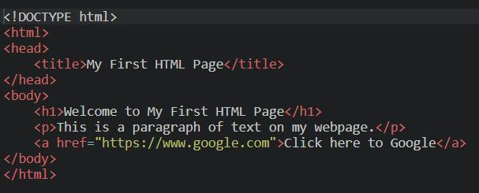

Output :



# Experiment : 2

**Student Name: Piyush Sharma** UID: 23/SCA/BCA(CS)/028

**Create a web page that displays your name to the screen.**

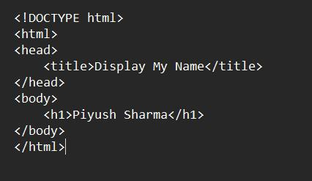

**Output:**



# Experiment : 3

**Student Name: Piyush Sharma** UID: 23/SCA/BCA(CS)/028

Create a web page and show the output from 1 to 10 in separate lines.

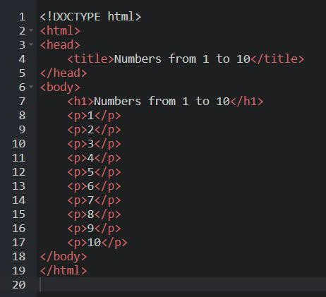

Output:

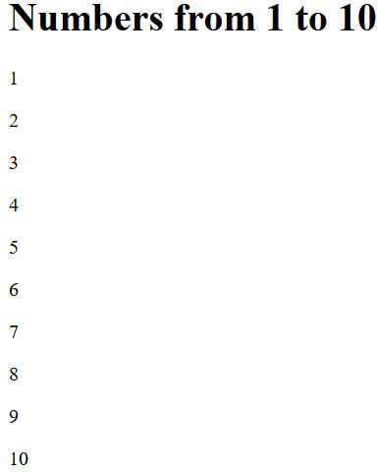

# Experiment : 4

**Student Name: Piyush Sharma** UID: 23/SCA/BCA(CS)/028

Create a web page and show the output from 1 to 10 in separate lines, each number being in different colour.

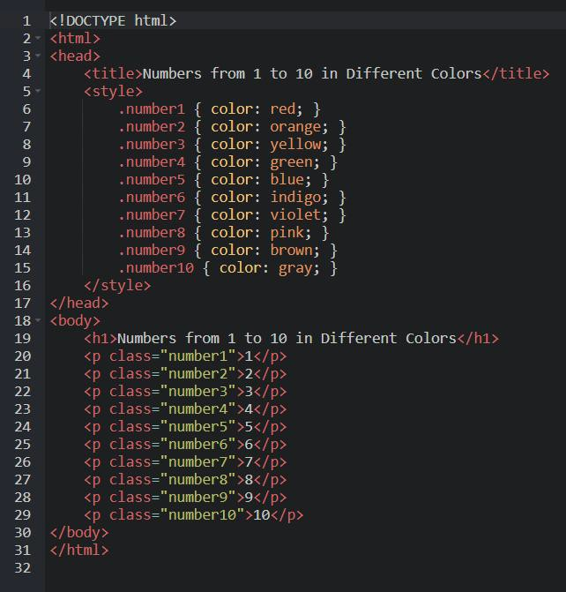

Output:



# Experiment : 5

**Student Name: Piyush Sharma** UID: 23/SCA/BCA(CS)/028

How do I make a picture as a background on my web pages?

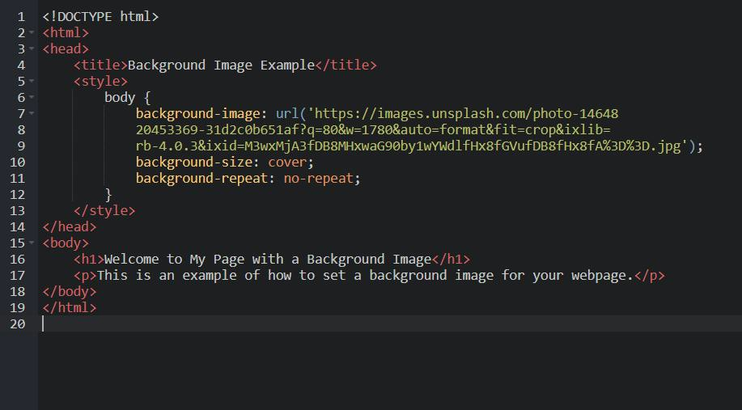

Output:



# Experiment : 6

**Student Name: Piyush Sharma** UID: 23/SCA/BCA(CS)/028

Create a web page to print a paragraph with 4-5 sentences, each sentence shall have a different font.

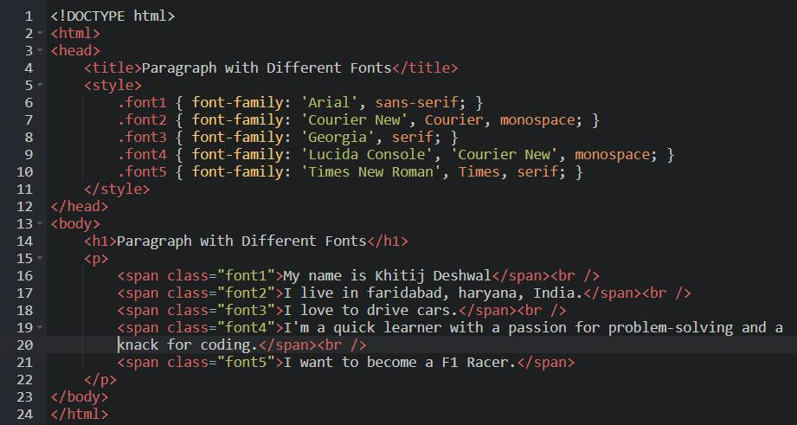

Output:

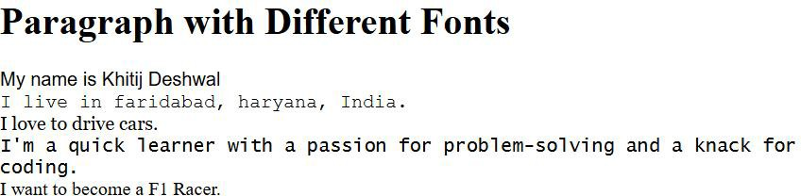

# Experiment : 7

**Student Name: Piyush Sharma** UID: 23/SCA/BCA(CS)/028

Write HTML code to print a paragraph that is description of a book, it shall include the title of the book, its author name; name and title

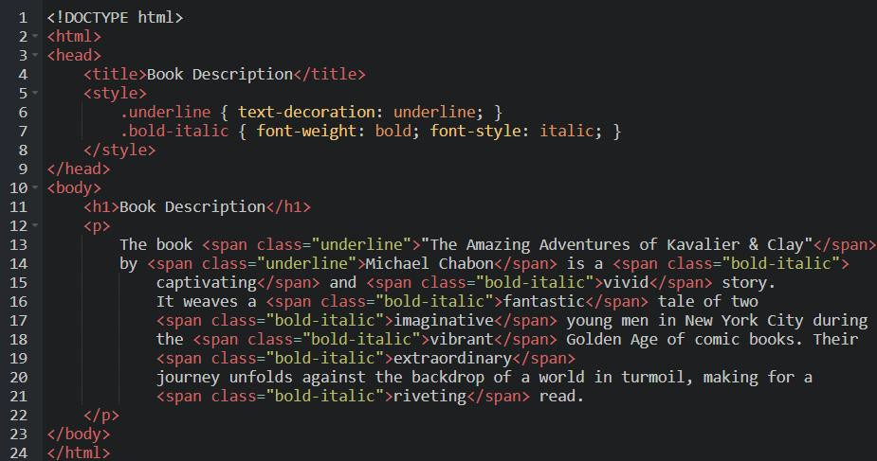

should be underlined and all adjectives shall be bold and Italics.

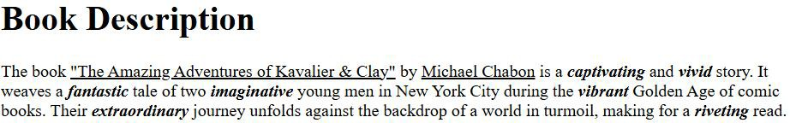

Output:

# Experiment : 8

**Student Name: Piyush Sharma** UID: 23/SCA/BCA(CS)/028

Write HTML code to print your name using Heading tag, every letter shall be of different heading size

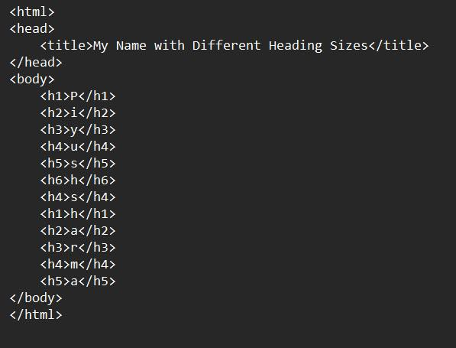

Output:

# Experiment : 9

**Student Name: Piyush Sharma** UID: 23/SCA/BCA(CS)/028

Write HTML code to print the sequence of numbers 1-20. Each number shall be in different line with number 2 next to it as subscript, an equal sign and the result.

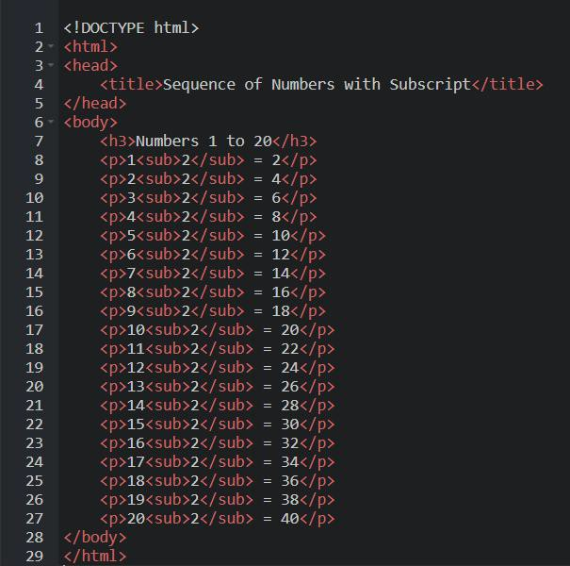

Output:

# Experiment : 10

**Student Name:Piyush Sharma** UID: 23/SCA/BCA(CS)/028

Write HTML code to display an image with border of size with width 200, height 200 pixels, leaving Hspace and Vspace of your choice with image hanging in the right side on the screen.

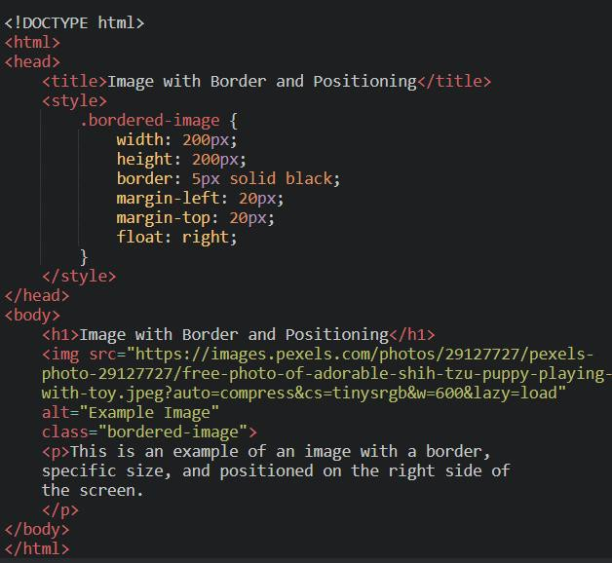

Output:

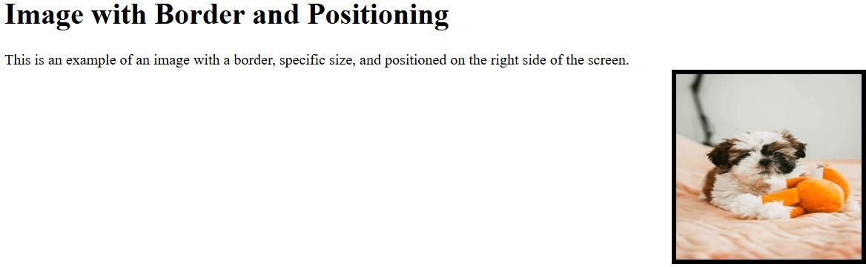

# Experiment : 11

**Student Name: Piyush Sharma** UID: 23/SCA/BCA(CS)/028

Write HTML code to create a web page with heading. The heading shall be displayed at the top-center of the page and the image shall be at the center, just below the heading

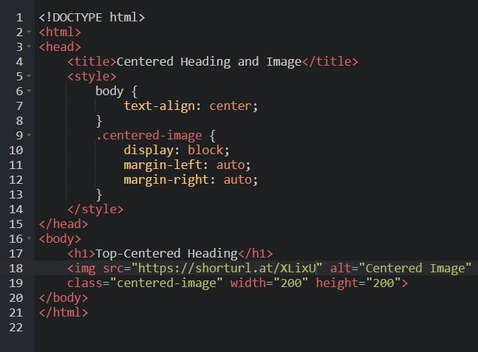

Output:

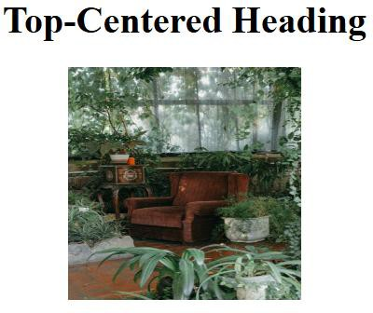

# Experiment : 12

**Student Name: Piyush Sharma**

UID: 23/SCA/BCA(CS)/028

Write HTML code using Multimedia tags.

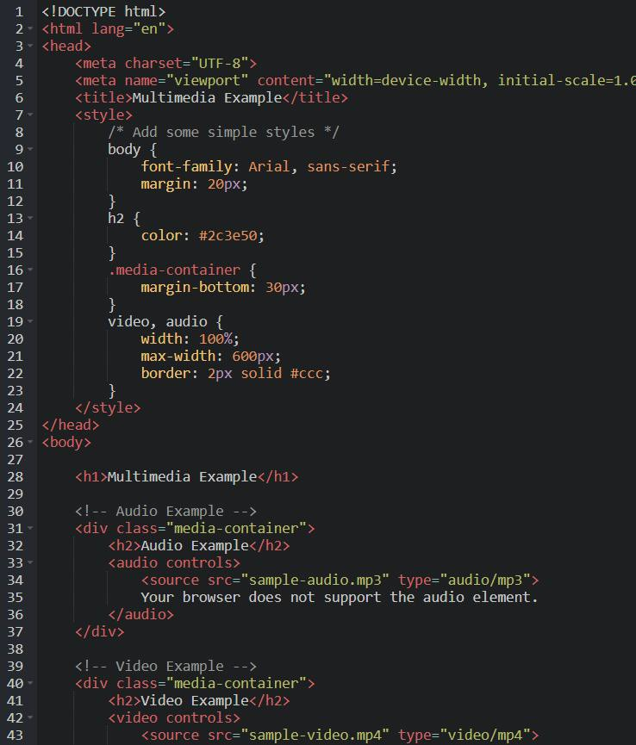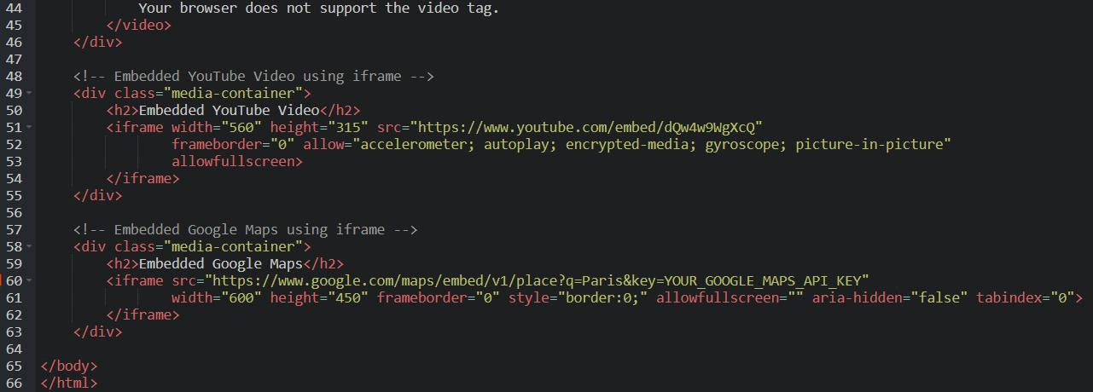

Output:

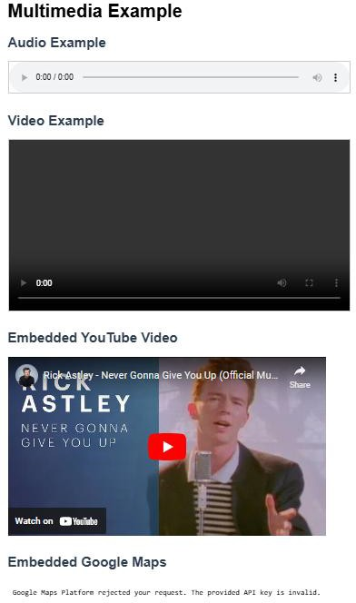

# Experiment : 13

**Student Name: Piyush Sharma** UID: 23/SCA/BCA(CS)/028

Create a Table using Rowspan and Colspan taking example of student Record.

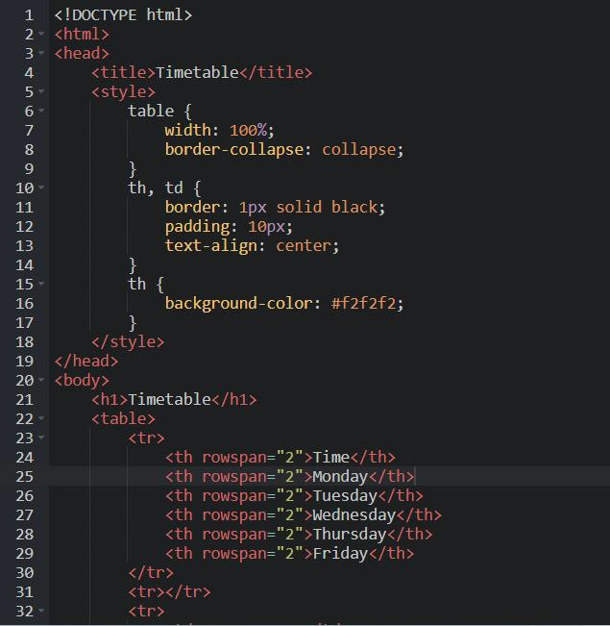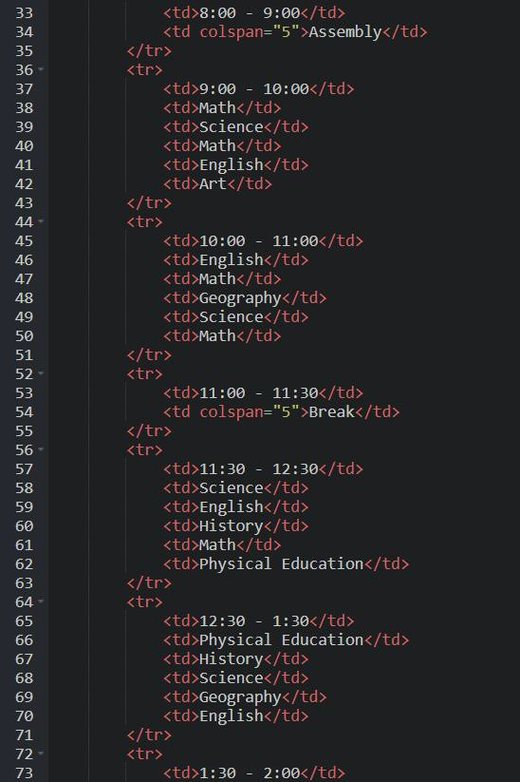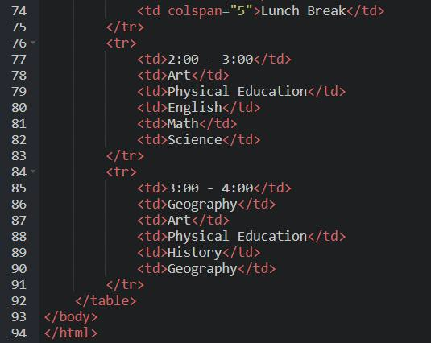

**Output:**

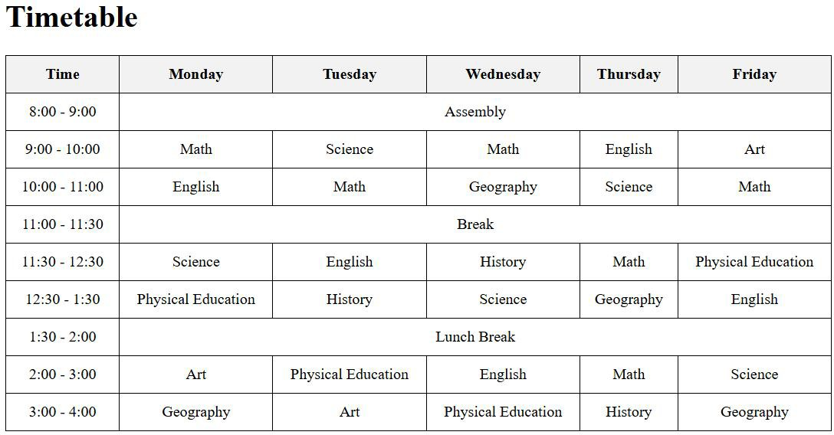

# Experiment : 14

**Student Name: Piyush Sharma** UID: 23/SCA/BCA(CS)/028

Write HTML code using table tag <table> and cellpadding and cellspacing as its attributes.

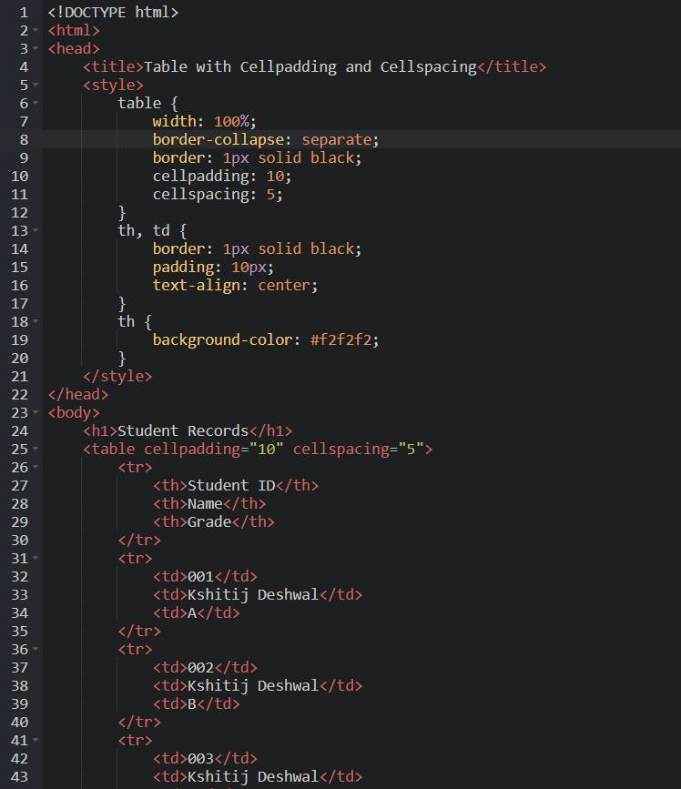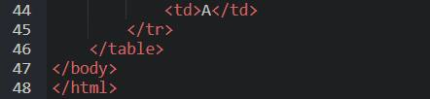

Output:

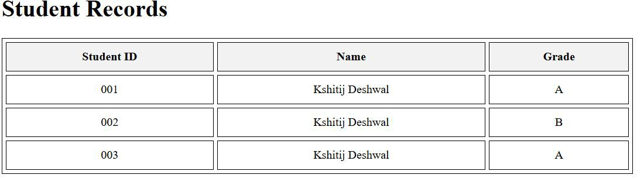

# Experiment : 15

**Student Name: Piyush Sharma UID: 23/SCA/BCA(CS)/028**

Create unordered, ordered and definition Lists taking example of your subjects in MCA IST, IInd and IIIrd

Semester.

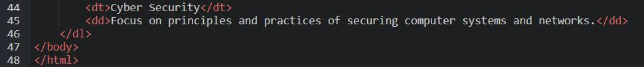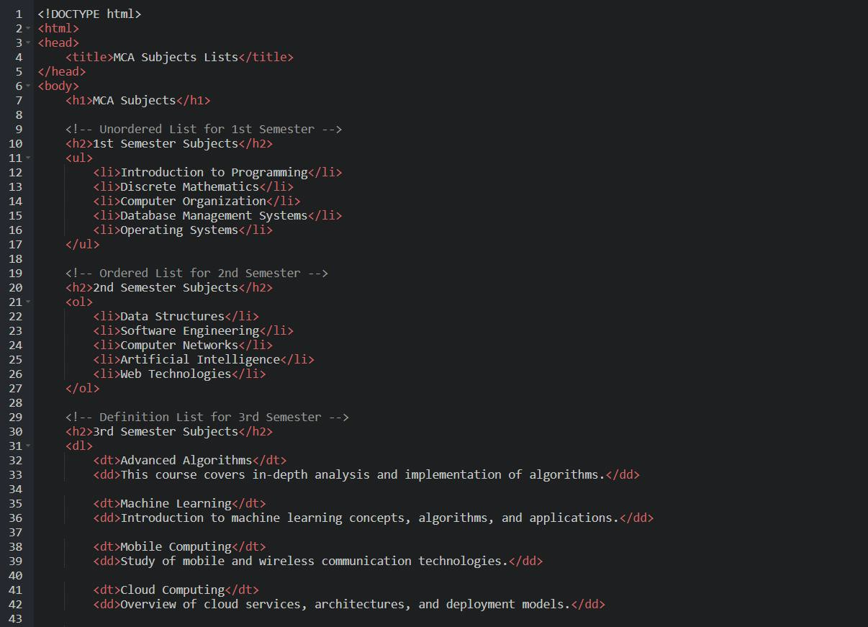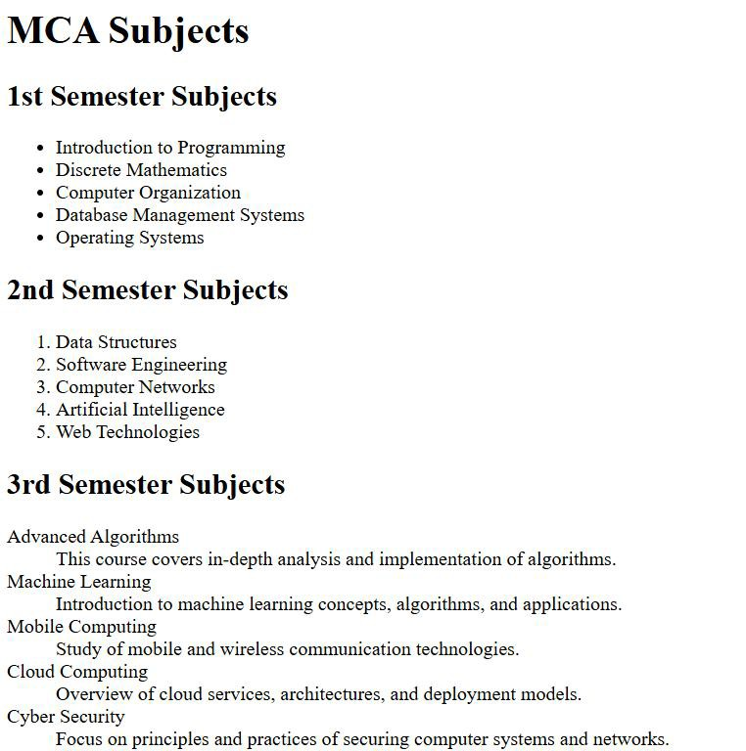

Output:

# Experiment : 16

**Student Name: Piyush Sharma** UID: 23/SCA/BCA(CS)/028

Write HTML code using <frameset> and <frame> tag with all its attributes

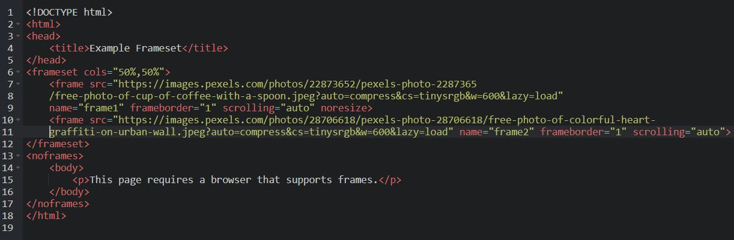

Output:



# Experiment : 17

**Student Name: Piyush Sharma** UID: 23/SCA/BCA(CS)/028

Write HTML code to design a form in HTML using controls and buttons such as Teaxtbox, Textarea, password, submit button, browse button, drop-down menu.

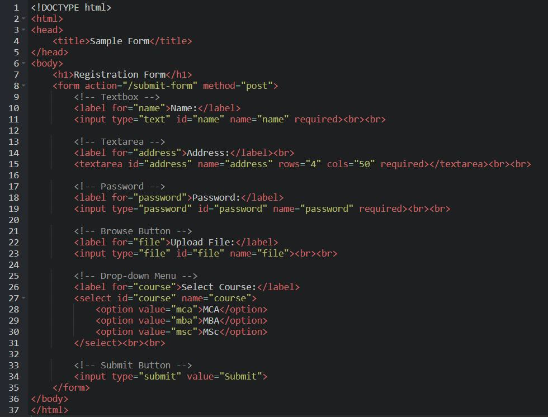

Output:

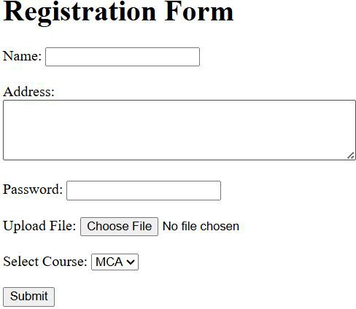

# Experiment : 18

**Student Name: Piyush Sharma** UID: 23/SCA/BCA(CS)/028

**Write HTML code to design a Registration Form in HTML.**

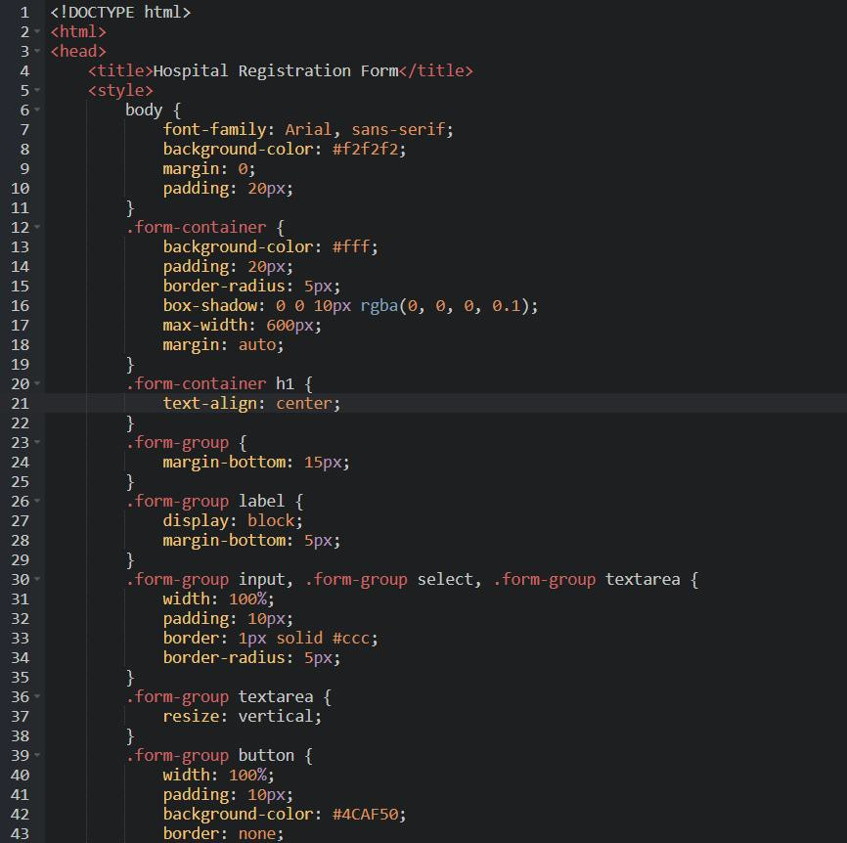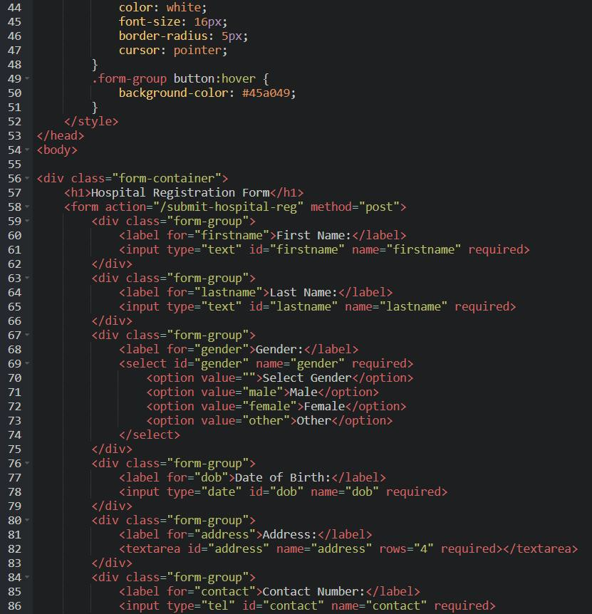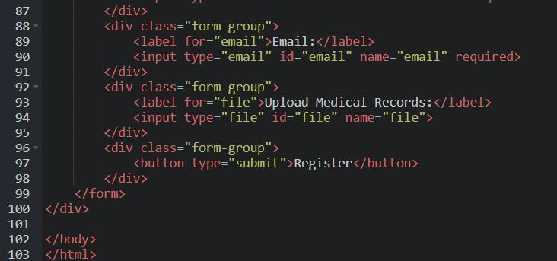

*Output:*

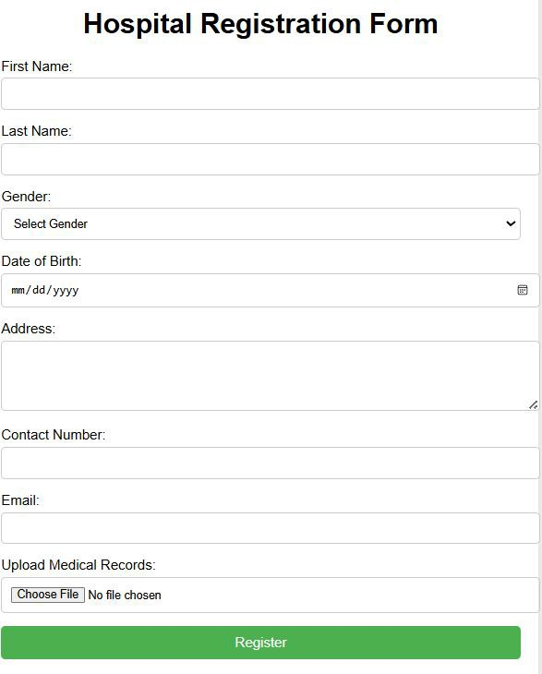

# Experiment : 19

**Student Name: Piyush Sharma** UID: 23/SCA/BCA(CS)/028

**Write HTML code to design a student admission Form in HTML.**

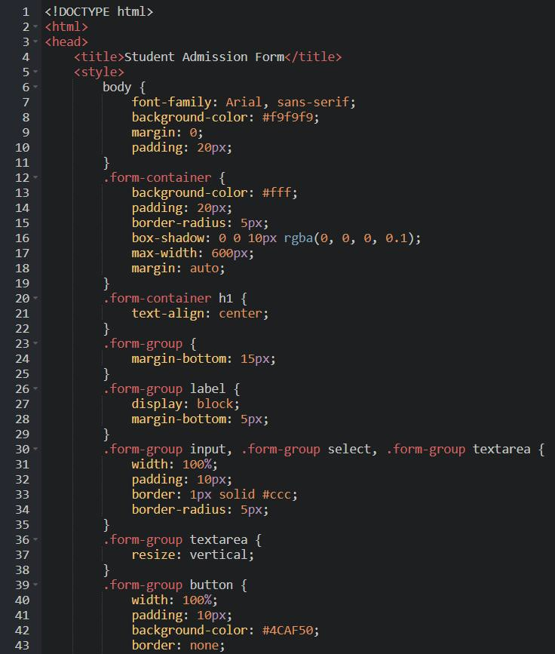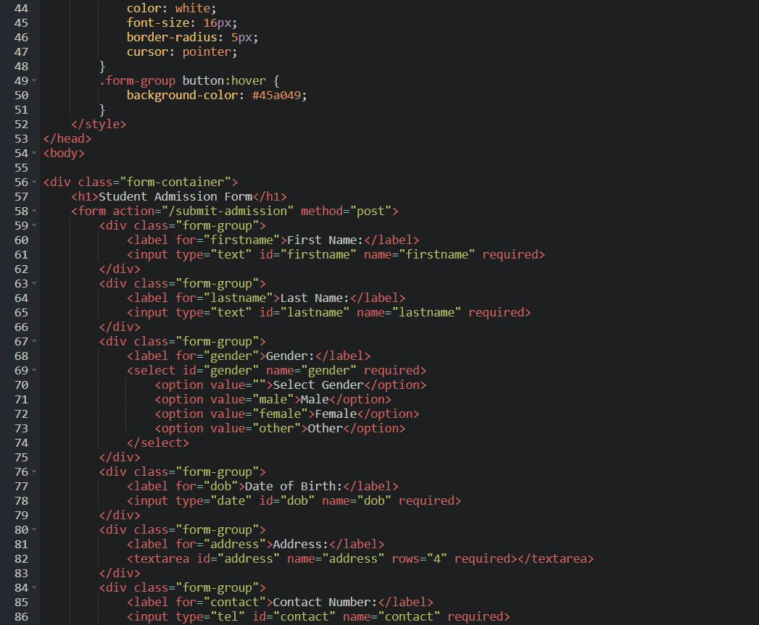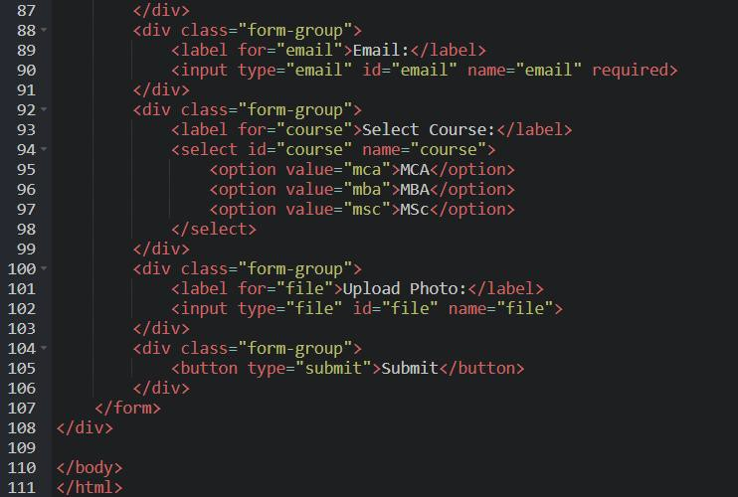

**Output:**

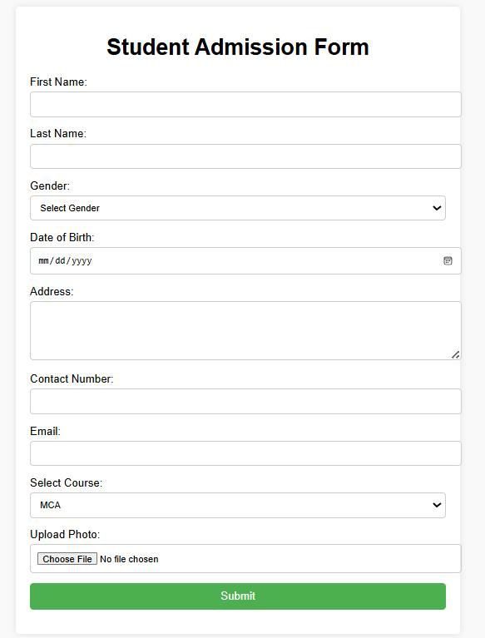

# Experiment : 20

**Student Name: Piyush Sharma** UID: 23/SCA/BCA(CS)/028

**Create a proper home page of your own using any components and styles.**

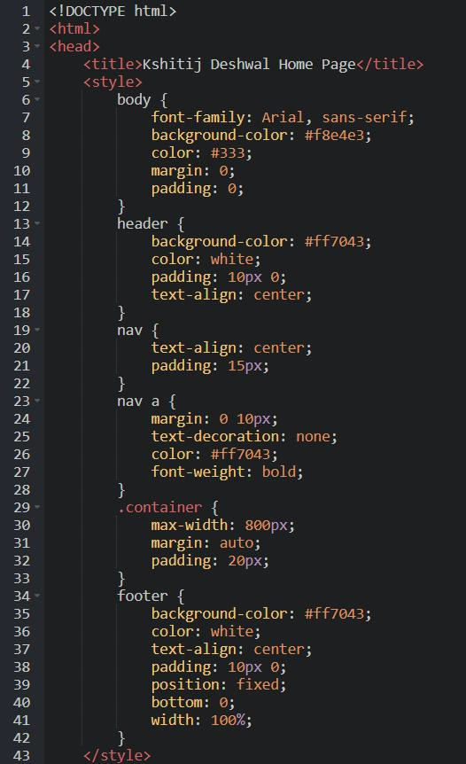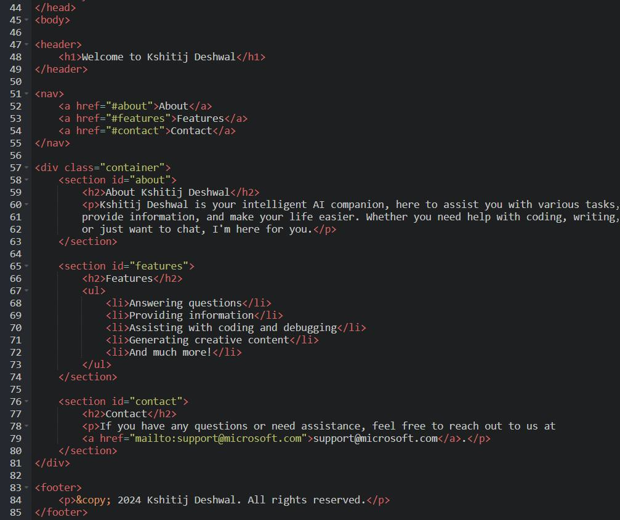

**Output:**



# Experiment : 21

**Student Name: Piyush Sharma** UID: 23/SCA/BCA(CS)/028

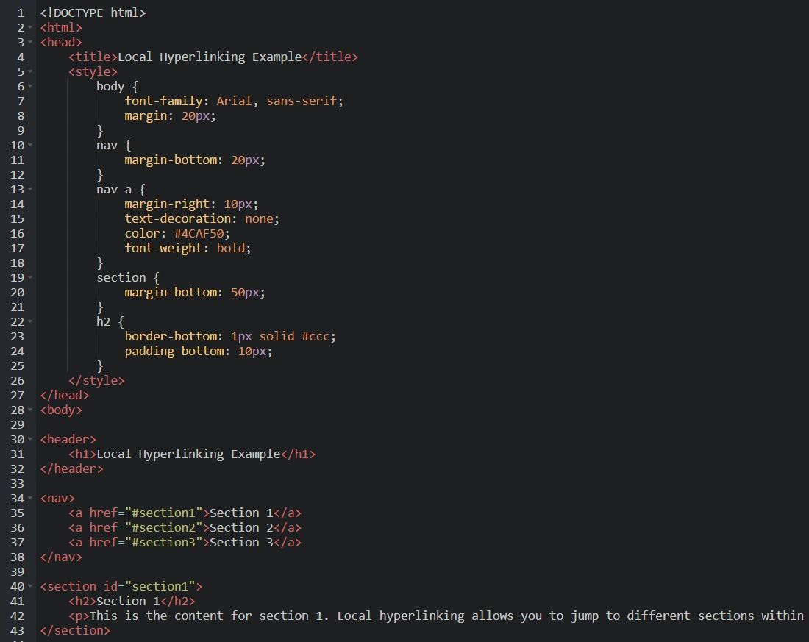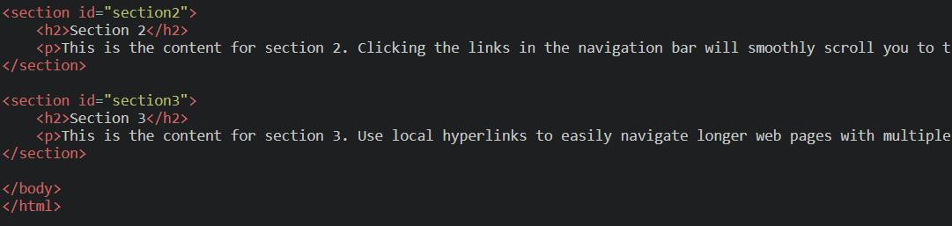

Output:

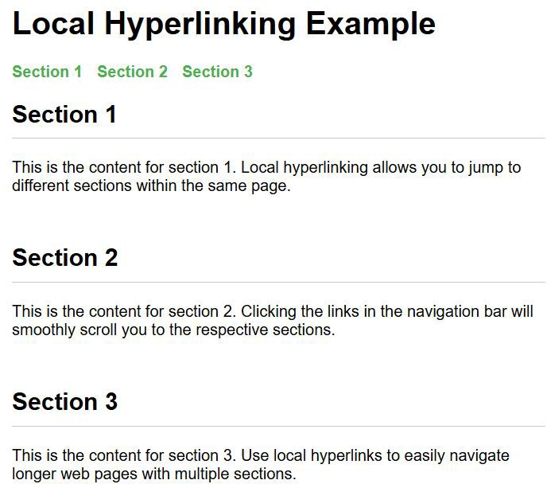

# Experiment : 22

**Student Name: Piyush Sharma** UID: 23/SCA/BCA(CS)/028

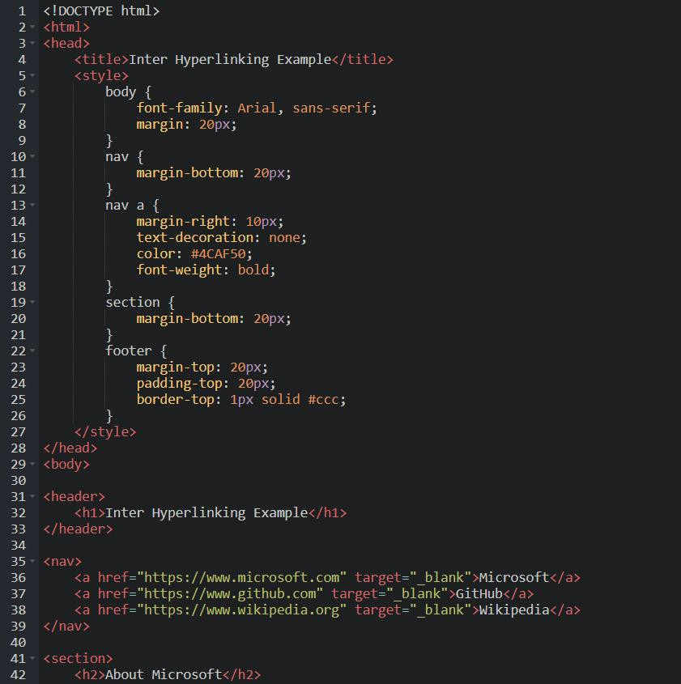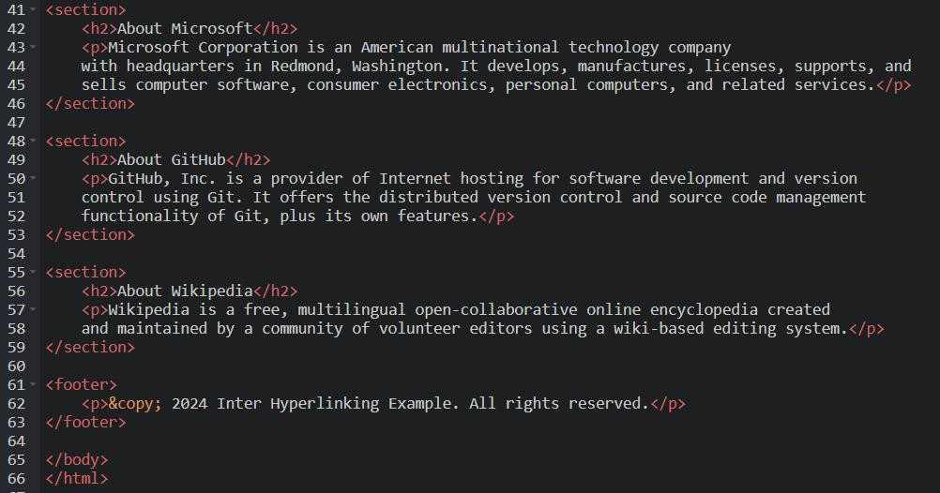

Output:

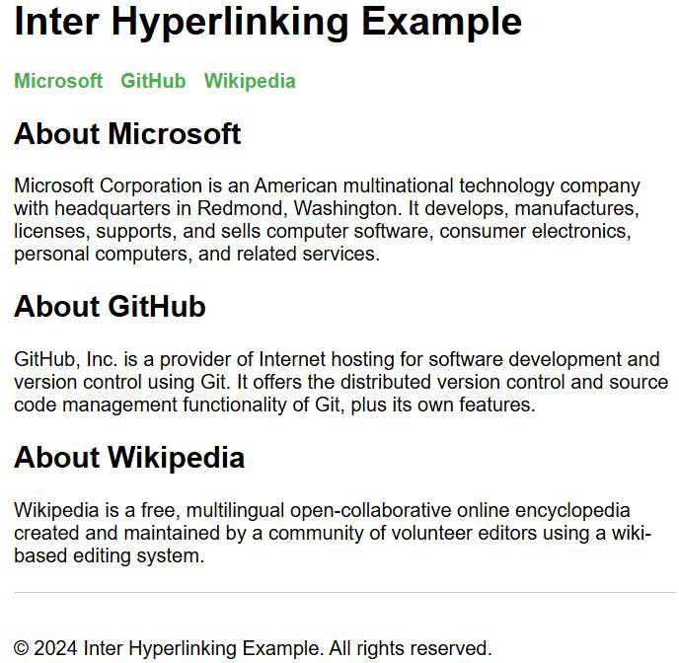

# Experiment : 23

**Student Name: Piyush Sharma** UID: 23/SCA/BCA(CS)/028

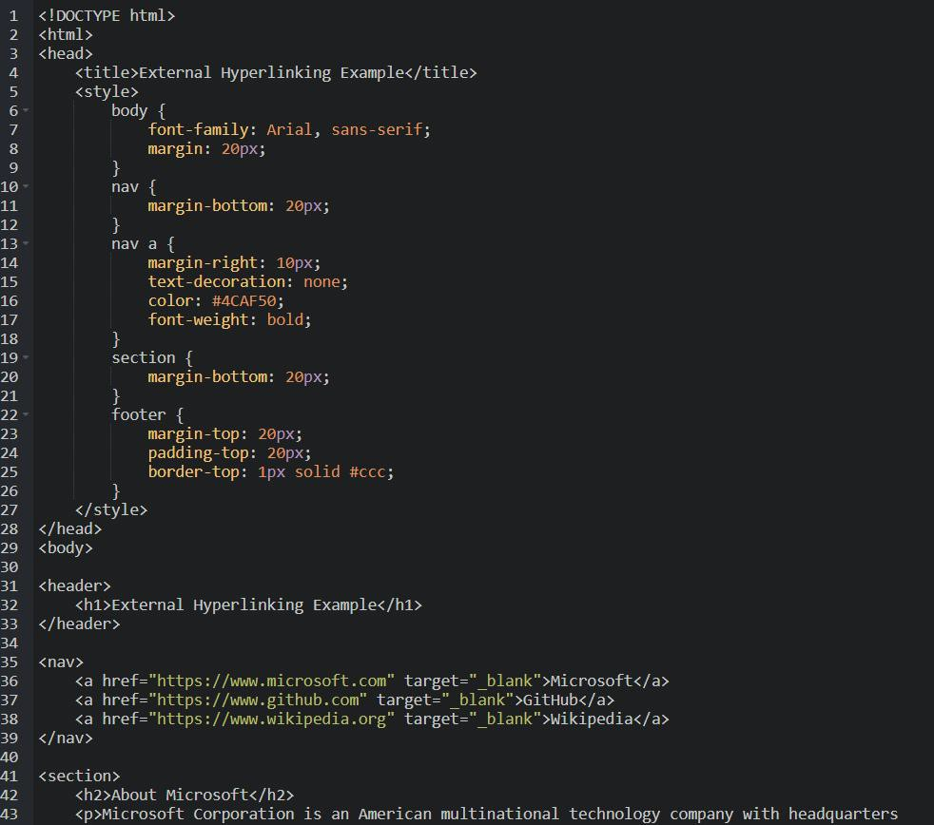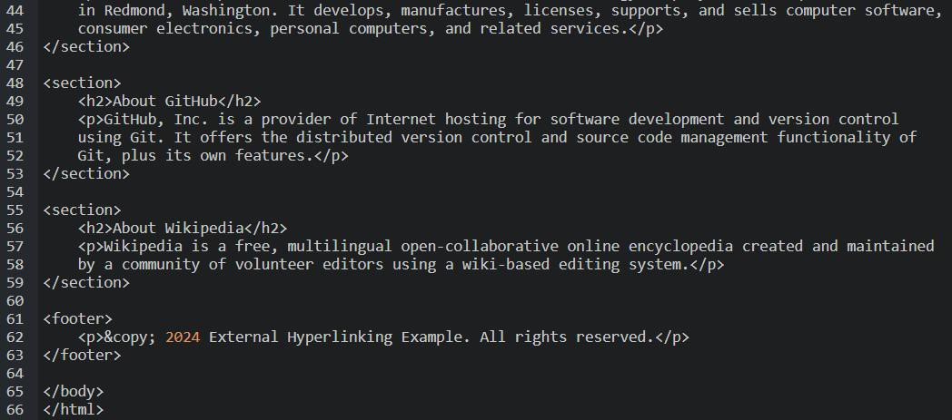

Output:

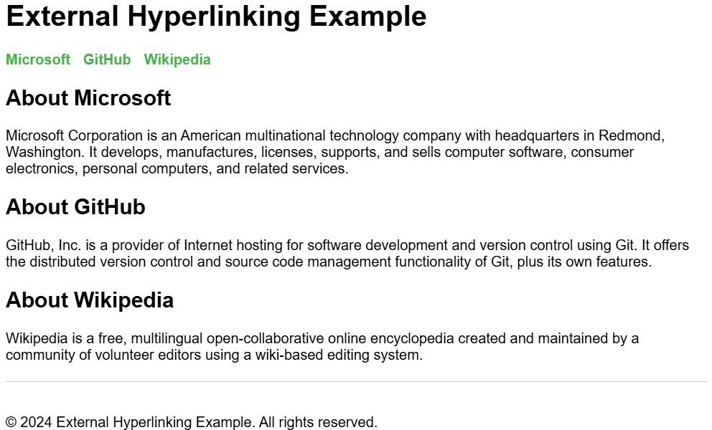

# Experiment : 24

**Student Name: Piyush Sharma** UID: 23/SCA/BCA(CS)/028

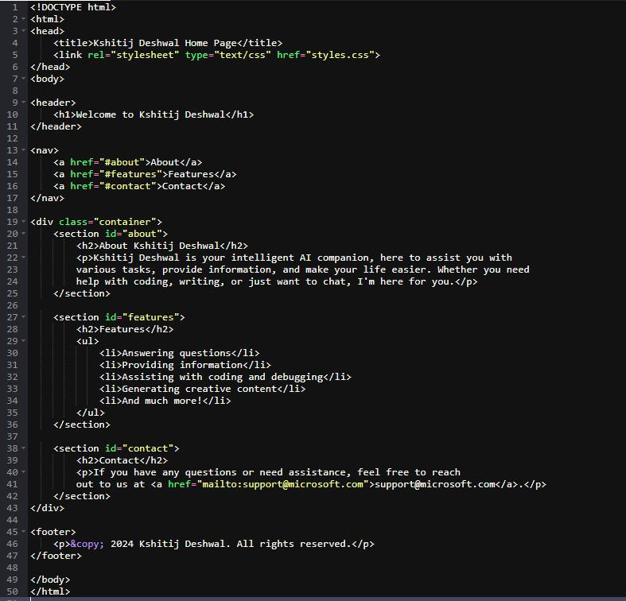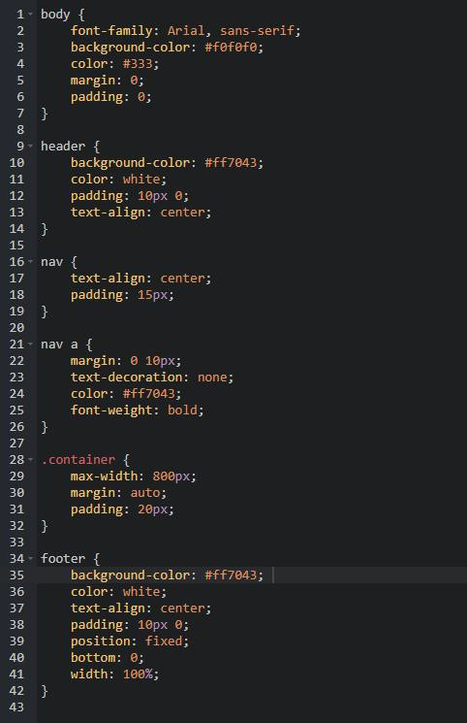

Output:

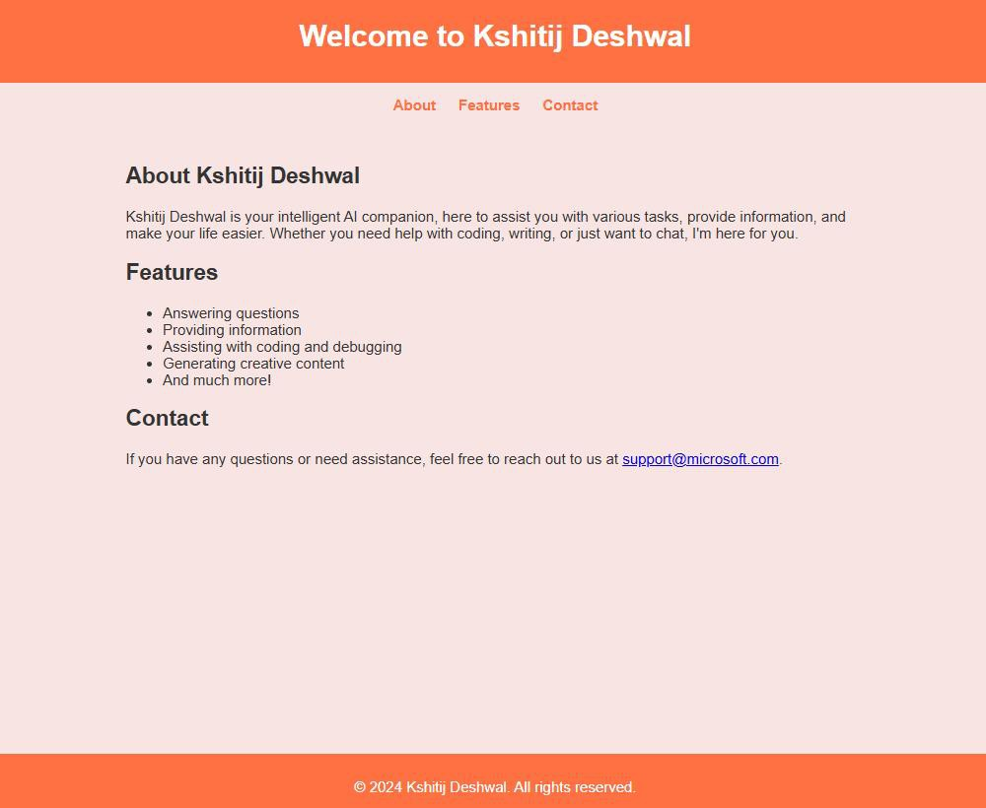

# Experiment : 25

**Student Name: Piyush Sharma** UID: 23/SCA/BCA(CS)/028

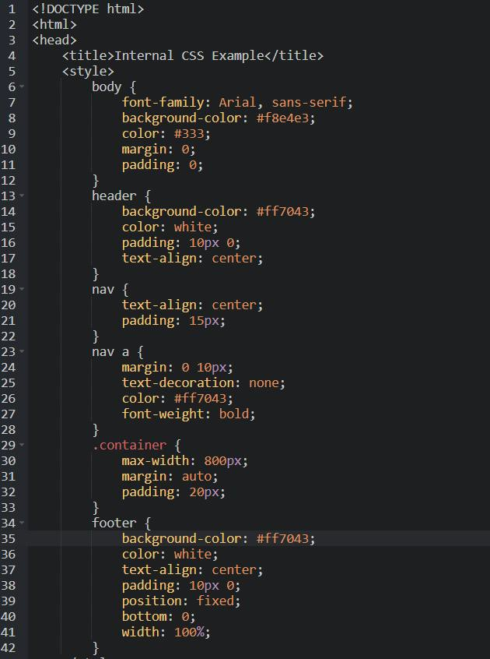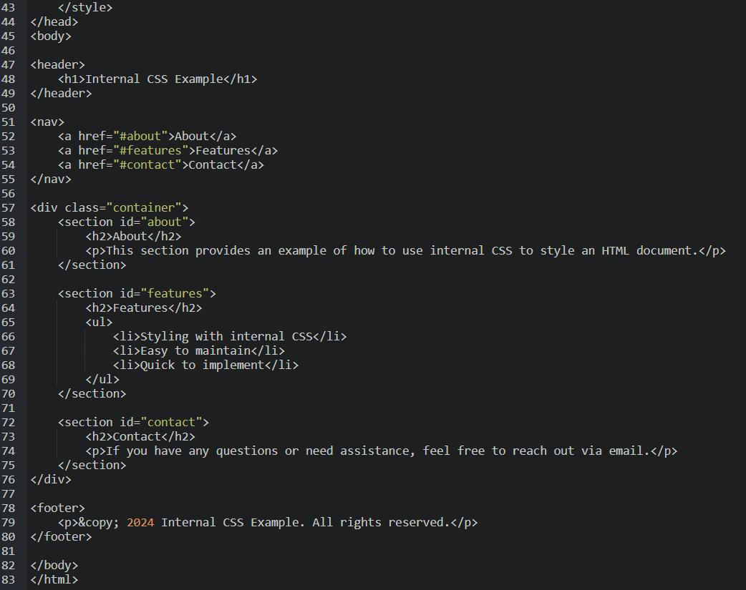

Output:

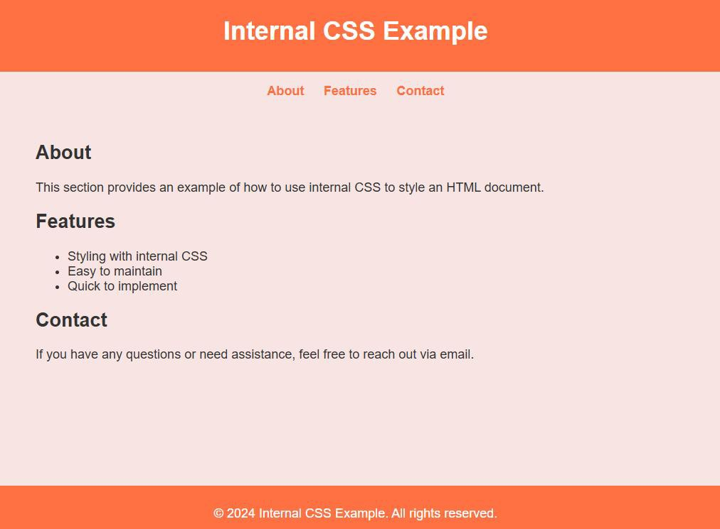

# Experiment : 26

**Student Name: Piyush Sharma** UID: 23/SCA/BCA(CS)/028

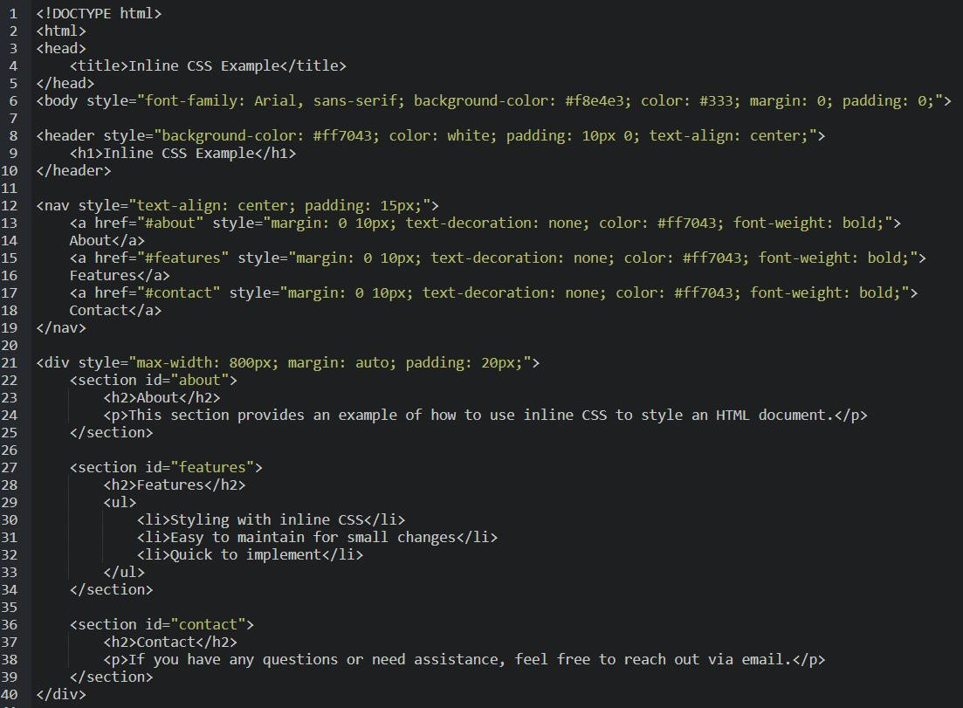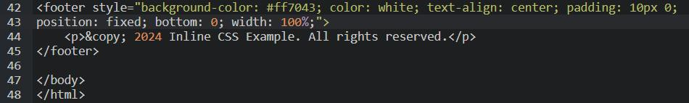

Output:

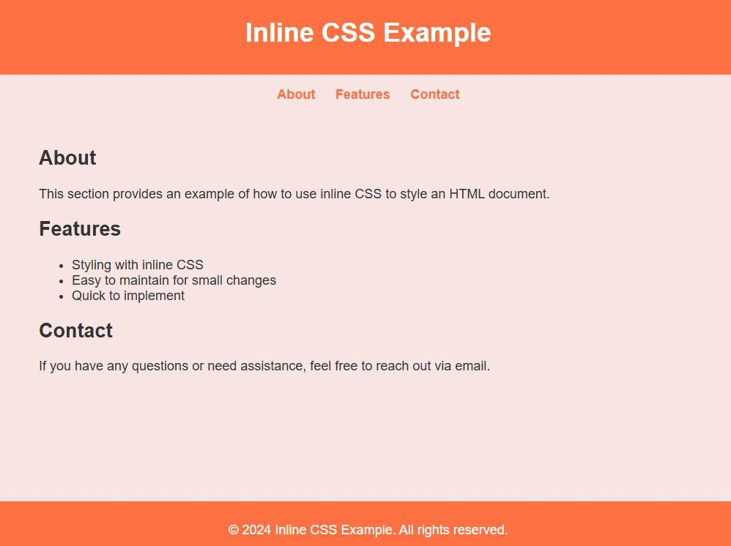

# Experiment : 27

**Student Name: Piyush Sharma**

UID: 23/SCA/BCA(CS)/028

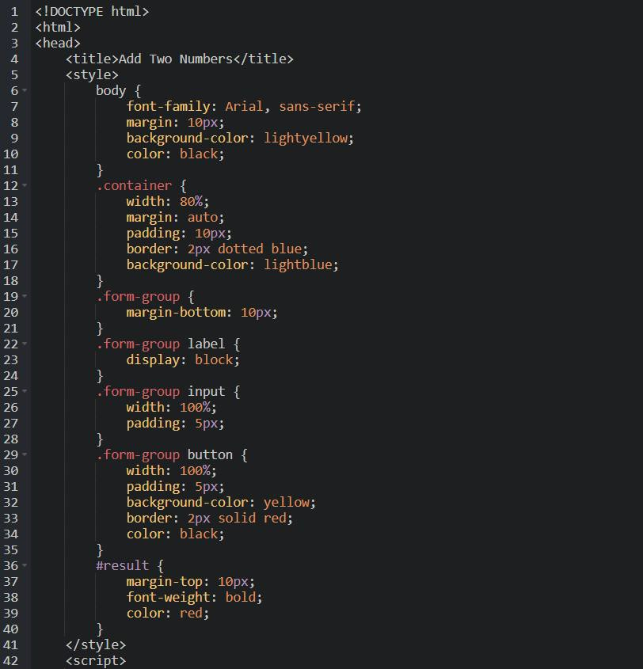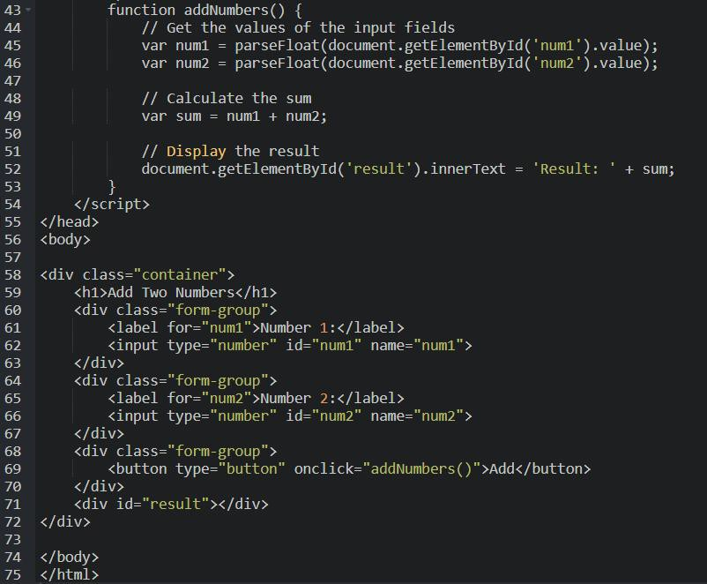

Output:

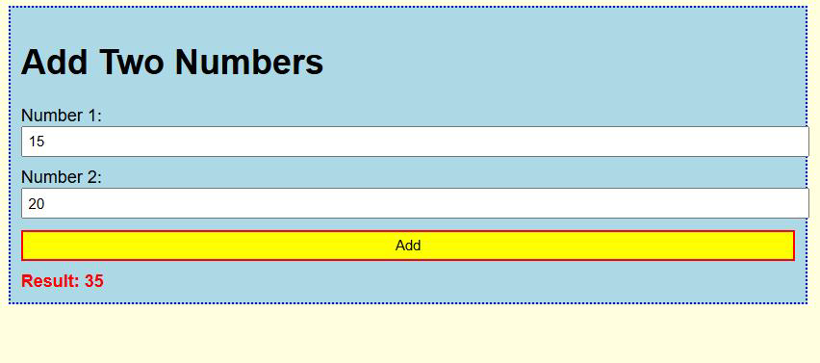

# Experiment : 28

**Student Name: Piyush Sharma** UID: 23/SCA/BCA(CS)/028

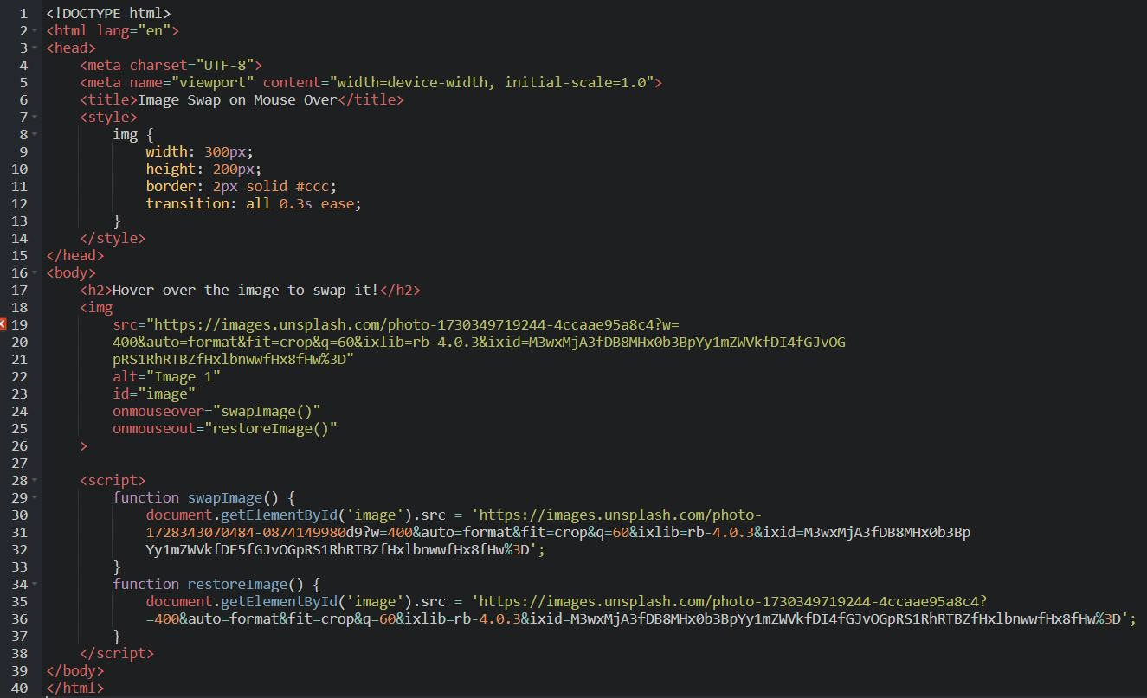

Output:

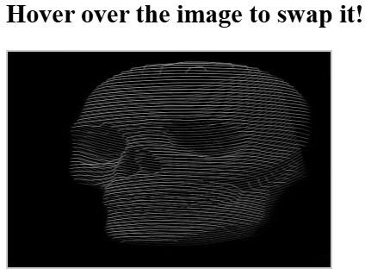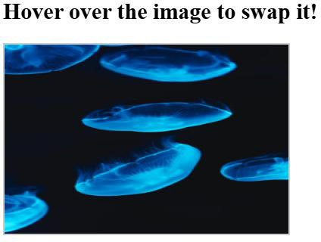

# Experiment : 29

**Student Name: Piyush Sharma** UID: 23/SCA/BCA(CS)/028

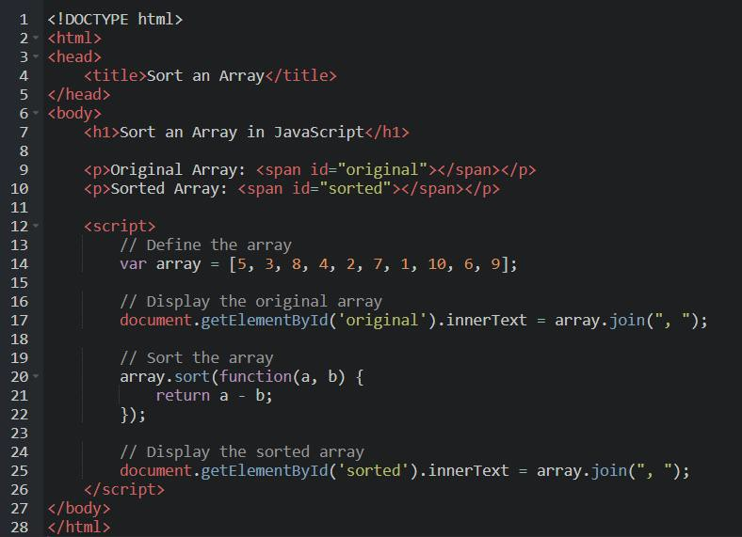

Output:

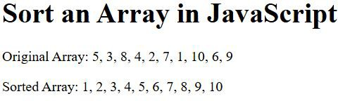

# Experiment : 30

**Student Name: Piyush Sharma** UID: 23/SCA/BCA(CS)/028

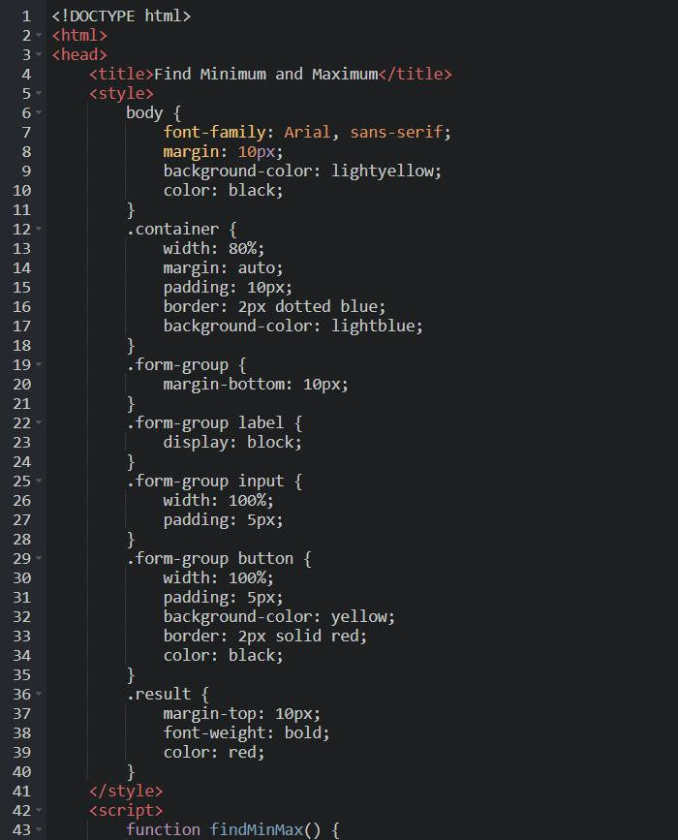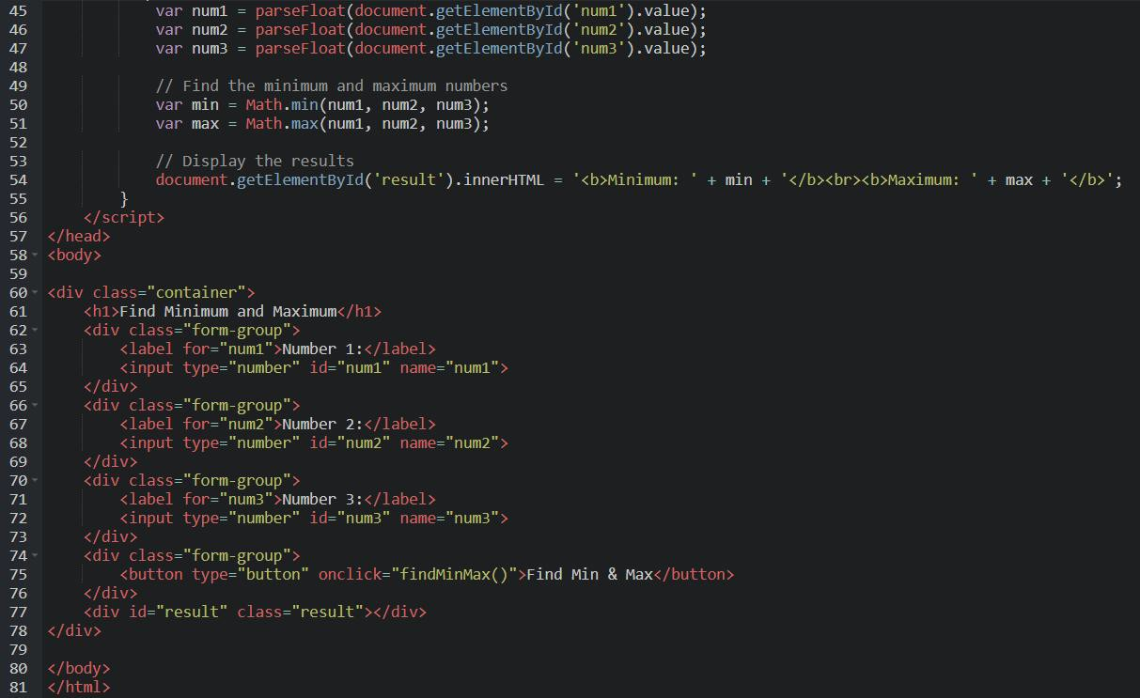

Output:

